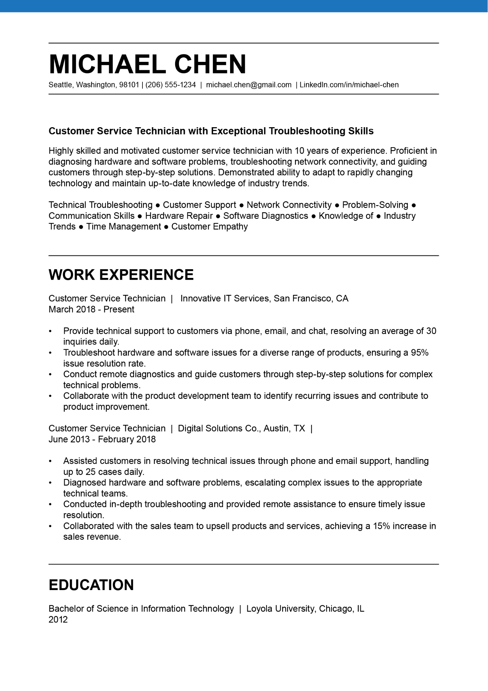
MICHAEL CHEN
Seattle, Washington, 98101 | (206) 555-1234 | michael.chen@gmail.com | LinkedIn.com/in/michael-chen
Customer Service Technician with Exceptional Troubleshooting Skills
Highly skilled and motivated customer service technician with 10 years of experience. Proficient in diagnosing hardware and software problems, troubleshooting network connectivity, and guiding customers through step-by-step solutions. Demonstrated ability to adapt to rapidly changing technology and maintain up-to-date knowledge of industry trends.
Technical Troubleshooting Customer Support Network Connectivity
Problem-Solving
Communication Skills ● Hardware Repair ● Software Diagnostics • Knowledge of ● Industry Trends Time Management ● Customer Empathy
WORK EXPERIENCE
Customer Service Technician | Innovative IT Services, San Francisco, CA
March 2018 - Present
•
Provide technical support to customers via phone, email, and chat, resolving an average of 30 inquiries daily.
Troubleshoot hardware and software issues for a diverse range of products, ensuring a 95% issue resolution rate.
Conduct remote diagnostics and guide customers through step-by-step solutions for complex technical problems.
Collaborate with the product development team to identify recurring issues and contribute to product improvement.
Customer Service Technician | Digital Solutions Co., Austin, TX |
June 2013 - February 2018
•
•
•
Assisted customers in resolving technical issues through phone and email support, handling up to 25 cases daily.
Diagnosed hardware and software problems, escalating complex issues to the appropriate technical teams.
Conducted in-depth troubleshooting and provided remote assistance to ensure timely issue resolution.
Collaborated with the sales team to upsell products and services, achieving a 15% increase in sales revenue.
EDUCATION
Bachelor of Science in Information Technology | Loyola University, Chicago, IL 2012

